Simple Bank Database

***Reference:*** <http://www.cs.ust.hk/~wilfred/dbweb/erd.html>

***Entity-Relationship Diagram***

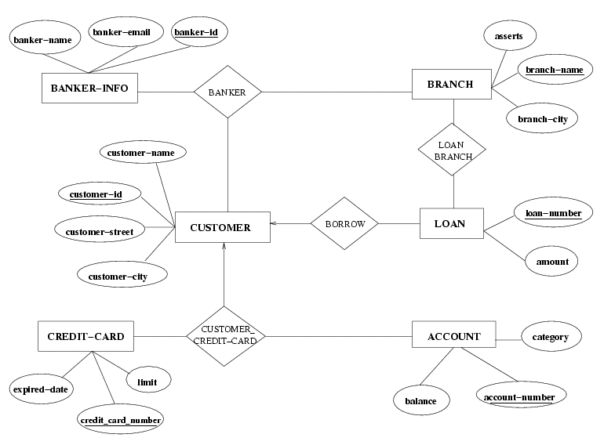

***Schemas***

**Branch-schema = (branch-name, assets, branch-city)**

branch-name is the name of a branch of the bank.

assets is the amount of money at the branch.

branch-city is the city at which the branch of the bank is located.

|  |  |  |
| --- | --- | --- |
| **branch-name** | **Assets** | **branch-city** |
| Clear Water Bay | 6,000,000 | Hong Kong |
| Downtown | 12,000,000 | Edmonton |
| Howe | 9,000,000 | Vancouver |
| McEwan | 6,000,000 | Calgary |
| Signal Hill | 8,000,000 | Calgary |
| Tsuen Wan | 8,000,000 | Hong Kong |

[**Back to Entity-Relationship Diagram**](http://www.cs.ust.hk/~wilfred/dbweb/erd.html#erd)

**Loan-schema = (branch-name, loan-number, amount)**

branch-name is the name of a branch which grants the loan.

loan-number is the identifier of the loan.

amount is the amount of money in the loan.

|  |  |  |
| --- | --- | --- |
| **branch-name** | **loan-number** | **amount** |
| Clear Water Bay | 1 | 150,000 |
| Howe | 2 | 20,000 |
| Howe | 3 | 600,000 |
| McEwan | 4 | 80,000 |
| Signal Hill | 5 | 90,000 |
| Signal Hill | 6 | 20,000 |
| Downtown | 7 | 30,000 |
| Downtown | 8 | 10,000 |
| Clear Water Bay | 9 | 250,000 |
| Tsuen Wan | 10 | 10,000 |

[**Back to Entity-Relationship Diagram**](http://www.cs.ust.hk/~wilfred/dbweb/erd.html#erd)

**Borrower-schema = (customer-ID, loan-number)**

customer-ID is the identifier of the customer of the bank

loan-number is the identifier of the loan that the customer borrows in the bank.

|  |  |
| --- | --- |
| **customer-id** | **loan-number** |
| C8392380567 | 1 |
| C8392380567 | 9 |
| C8954385123 | 10 |
| C2389490434 | 4 |
| C9384899234 | 5 |
| C0930238083 | 6 |
| C3487327487 | 7 |
| C3249893849 | 8 |
| C3948938442 | 3 |
| C2394893848 | 2 |

[**Back to Entity-Relationship Diagram**](http://www.cs.ust.hk/~wilfred/dbweb/erd.html#erd)

**Customer-schema = (customer-ID, customer-name, customer-street, customer-city)**

customer-ID is the identifier of a customer of the bank

customer-name is the name of the customer

customer-street is the street in the address of the customer

customer-city is the city in the address of the customer

|  |  |  |  |
| --- | --- | --- | --- |
| **customer-id** | **customer-name** | **customer-street** | **customer-city** |
| C8392380567 | Amy | Ping Ting Road | Hong Kong |
| C8954385123 | Bob | Texaco Road | Hong Kong |
| C2389490434 | Carson | Deerfoot Trail | Calgary |
| C9384899234 | David | Unversity Drive | Calgary |
| C0930238083 | John | Ogden Road | Calgary |
| C3487327487 | Linda | Kingsway Drive | Edmonton |
| C3249893849 | Mandy | Victoria Road | Edmonton |
| C3948938442 | Paul | Hornby Road | Vancouver |
| C2394893848 | Ricky | Howe Road | Vancouver |

[**Back to Entity-Relationship Diagram**](http://www.cs.ust.hk/~wilfred/dbweb/erd.html#erd)

**Credit-card-schema = (credit-card-number, limit, expiry-date)**

credit-card-number is the number printed on a credit card issued by the bank to a customer

limit is the maximum amount of money that a customer can consume using the credit card

expiry-date is the expiry date of the credit card

|  |  |  |
| --- | --- | --- |
| **credit-card-number** | **limit** | **expiry-date** |
| 0000-1111-1111-1111 | $5,000.00 | 1-Mar-02 |
| 0000-1111-1111-2222 | $10,000.00 | 1-Dec-05 |
| 0000-2222-2222-2222 | $5,000.00 | 1-Dec-03 |
| 0000-3333-3333-3333 | $3,000.00 | 1-Nov-04 |
| 0000-4444-4444-4444 | $20,000.00 | 1-Jan-03 |
| 0000-5555-5555-5555 | $10,000.00 | 1-Jan-05 |
| 0000-6666-6666-6666 | $10,000.00 | 1-Apr-04 |
| 0000-7777-7777-7777 | $10,000.00 | 1-Jan-05 |
| 0000-8888-8888-8888 | $20,000.00 | 1-Jan-02 |
| 0000-9999-9999-0000 | $3,000.00 | 1-Jan-03 |
| 0000-9999-9999-1111 | $10,000.00 | 1-Jan-02 |

[**Back to Entity-Relationship Diagram**](http://www.cs.ust.hk/~wilfred/dbweb/erd.html#erd)

**Customer-credit-card-schema = (customer-ID, credit-card-number, account-number)**

customer-ID is the identifier of a customer of the bank

credit-card-number is the number printed on the credit card issued by the bank to the customer

account-number is the number of a saving account owned by the customer in the bank

|  |  |  |
| --- | --- | --- |
| **customer-id** | **credit-card-number** | **account-number** |
| C8392380567 | 0000-1111-1111-1111 | 0-1-2222-3333-4444 |
| C8954385123 | 0000-2222-2222-2222 | 0-1-2222-2222-2222 |
| C2389490434 | 0000-3333-3333-3333 | 0-1-3333-3333-3333 |
| C9384899234 | 0000-4444-4444-4444 | 0-1-4444-4444-4444 |
| C0930238083 | 0000-5555-5555-5555 | 0-1-5555-5555-5555 |
| C3487327487 | 0000-6666-6666-6666 | 0-1-6666-6666-6666 |
| C3249893849 | 0000-7777-7777-7777 | 0-1-7777-7777-7777 |
| C3948938442 | 0000-8888-8888-8888 | 0-1-8888-8888-8888 |
| C2394893848 | 0000-9999-9999-0000 | 0-1-9999-9999-0000 |

[**Back to Entity-Relationship Diagram**](http://www.cs.ust.hk/~wilfred/dbweb/erd.html#erd)

**Account-schema = (account-number, category, balance)**

account-number is the number of a saving account owned by a customer.

category is the category of currency of the saving account such as HK dollars and foreign currency.

balance is the current balance of the amount of money in the saving account owned by a customer

|  |  |  |
| --- | --- | --- |
| **account-number** | **category** | **balance** |
| 0-1-2222-3333-4444 | Hong Kong dollars | 10,000.00 |
| 0-1-2222-3333-5555 | Hong Kong dollars | 500,000.00 |
| 0-1-2222-2222-2222 | Hong Kong dollars | 2,000.00 |
| 0-1-3333-3333-3333 | Canadian dollars | 1,000.00 |
| 0-1-4444-4444-4444 | Canadian dollars | 5,000.00 |
| 0-1-5555-5555-5555 | Canadian dollars | 5,000.00 |
| 0-1-6666-6666-6666 | Canadian dollars | 3,000.00 |
| 0-1-7777-7777-7777 | Canadian dollars | 2,000.00 |
| 0-1-8888-8888-8888 | Canadian dollars | 1,000.00 |
| 0-1-9999-9999-0000 | Canadian dollars | 1,000.00 |
| 0-1-9999-9999-1111 | Canadian dollars | 2,000.00 |

[**Back to Entity-Relationship Diagram**](http://www.cs.ust.hk/~wilfred/dbweb/erd.html#erd)

**Banker-info-schema = (banker-ID, banker-name, banker-email)**

banker-ID is the identifier of the banker working in the bank

banker-name is the name of the banker working in the bank

banker-email is the email of the banker working in the bank

|  |  |  |
| --- | --- | --- |
| **banker-id** | **banker-name** | **branch-email** |
| sta_rosana | Rosana | rosana@abcbank.com |
| sta_carina | Carina | carina@abcbank.com |
| sta_gloria | Gloria | gloria@abcbank.com |
| sta_elaine | Elaine | elaine@abcbank.com |
| sta_wynne | Wynne | wynne@abcbank.com |
| sta_shirley | Shirley | shirley@abcbank.com |
| sta_kadora | Kadora | kadora@abcbank.com |

[**Back to Entity-Relationship Diagram**](http://www.cs.ust.hk/~wilfred/dbweb/erd.html#erd)

**Banker-schema = (branch-name, customer-ID, banker-ID)**

branch-name is the name of the branch that the banker works in

customer-ID is the identifier of the customer that has the financial advisor (“personal banker”) in the branch

banker-ID is the identifier of the banker in the branch, who provides financial advice to the customer

|  |  |  |
| --- | --- | --- |
| **branch-name** | **customer-id** | **banker-id** |
| Clear Water Bay | C8392380567 | sta_rosana |
| Downtown | C3487327487 | sta_carina |
| Howe | C3948938442 | sta_gloria |
| McEwan | C9384899234 | sta_elaine |
| Signal Hill | C0930238083 | sta_wynne |
| Signal Hill | C8954385123 | sta_shirley |
| Tsuen Wan | C8954385123 | sta_kadora |